<https://www.youtube.com/watch?v=dDN-t69sa3U>

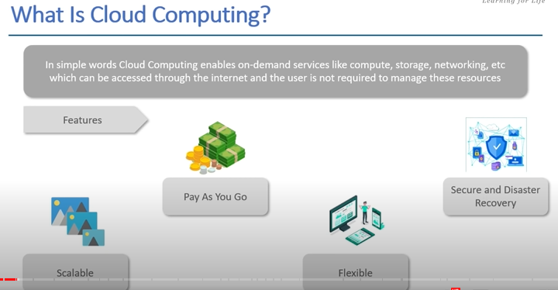

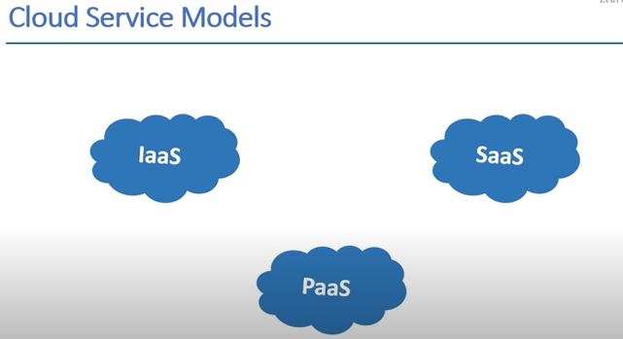

Iaas -> provide the resources but are managed by the user. Eg -> EC2

Paas-> manages some things like security , language etc.. others are managed by user.

Saas -> use ready to use software .. Just use it ,, Like Gmail

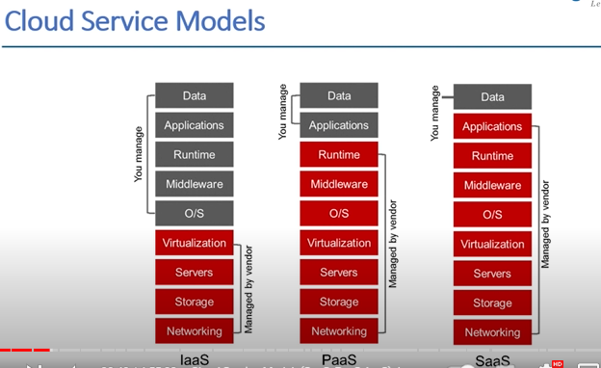

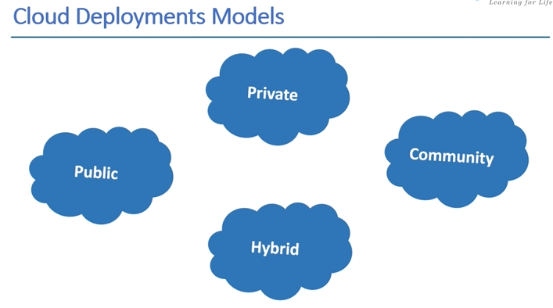

Aws , azure are public

India has 2 regions delhi,kolkata and Hyderabad

There are six AWS Direct Connect locations, all of which connect to the Asia Pacific (Mumbai) Region: two in Mumbai, one in Chennai, one in Hyderabad, one in Delhi, and one in Bangalore.

**Community** -> like data of aadhar is shared by various govt agencies ,, means it is shared , but it is safe also.

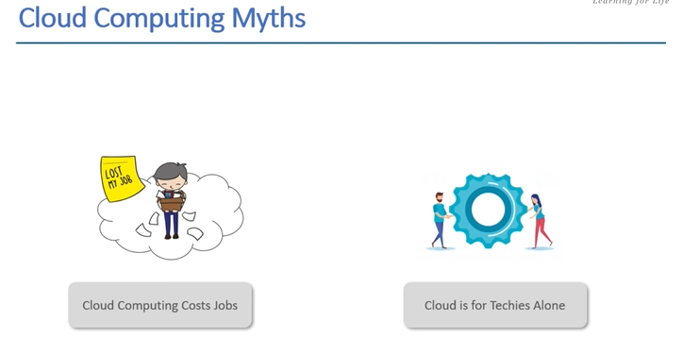

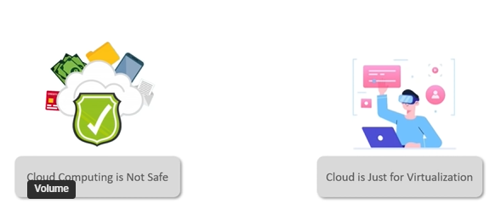

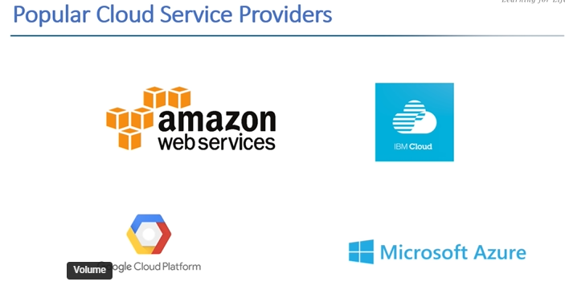

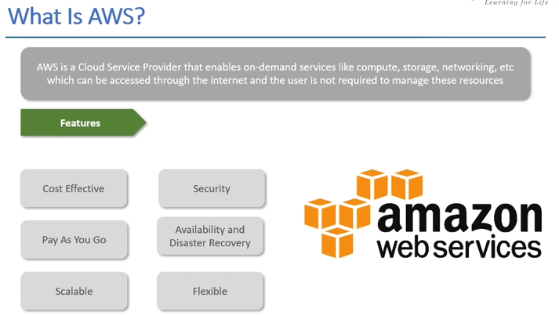

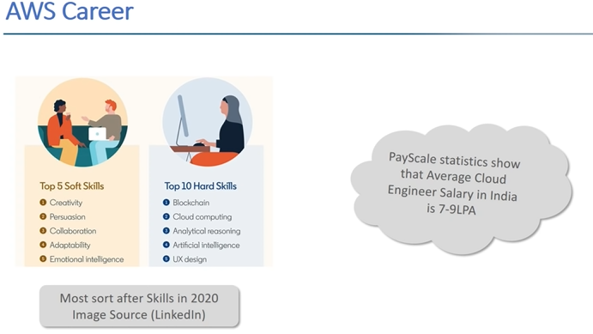

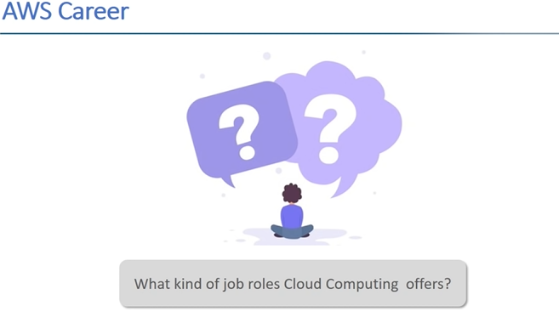

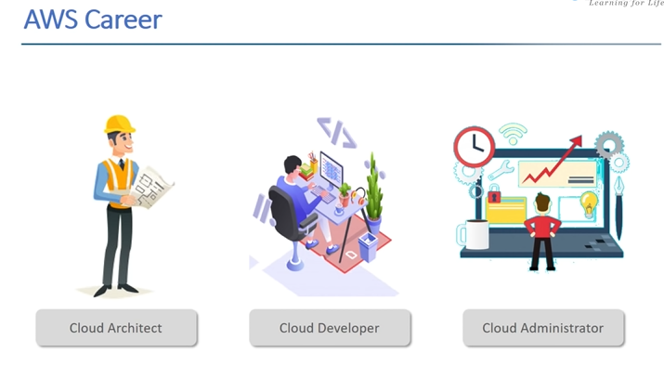

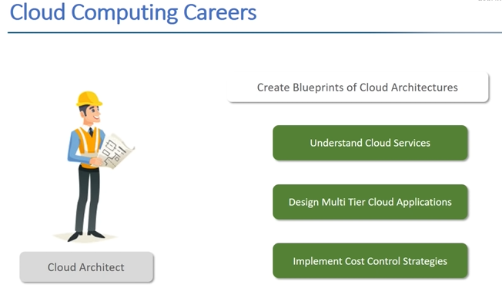

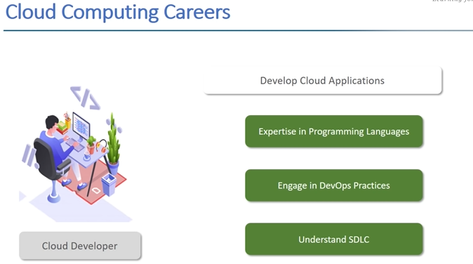

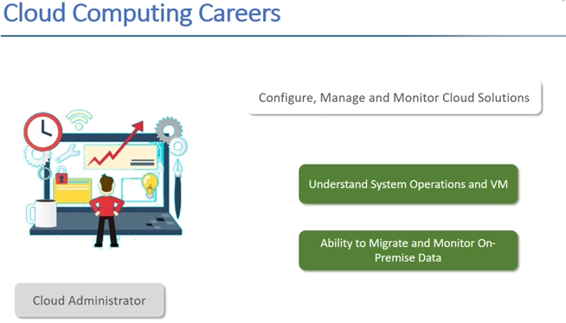

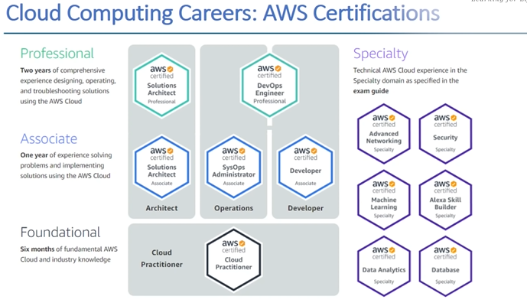

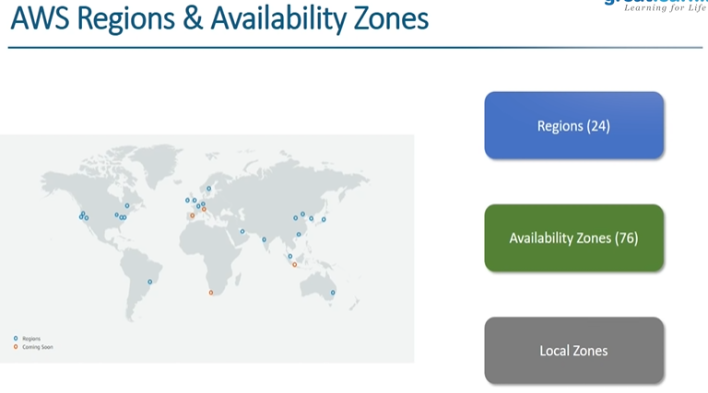has 2 regions now in india

Hyderabad and Mumbai

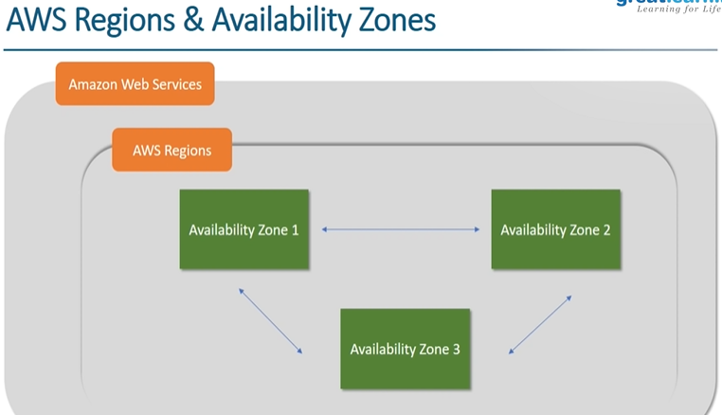

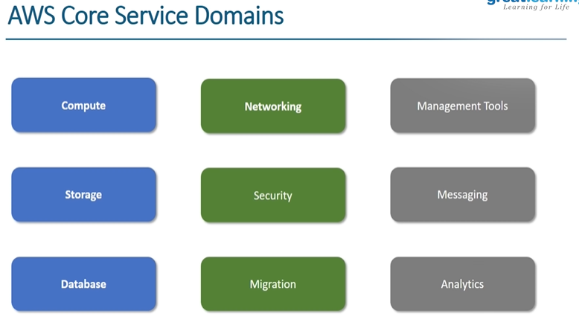ALL imp services provided by AWS

AWS Compute Services

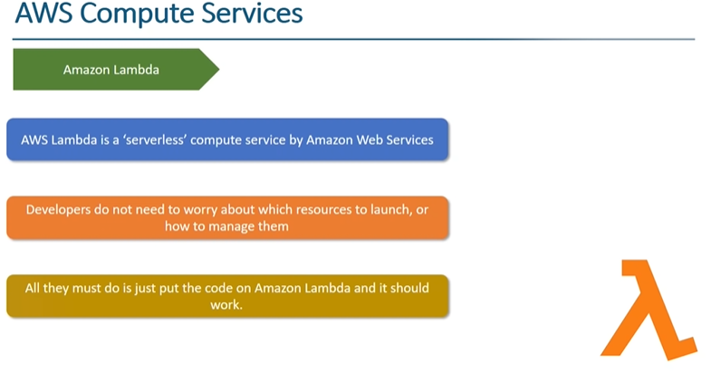

AWS Lambda is a serverless {Serverless is **a cloud-native development model that allows developers to build and run applications without having to manage servers**.}, event-driven compute service that lets you run code for virtually any type of application or backend service without provisioning or managing servers. You can trigger Lambda from over 200 AWS services and software as a service (SaaS) applications, and only pay for what you use.

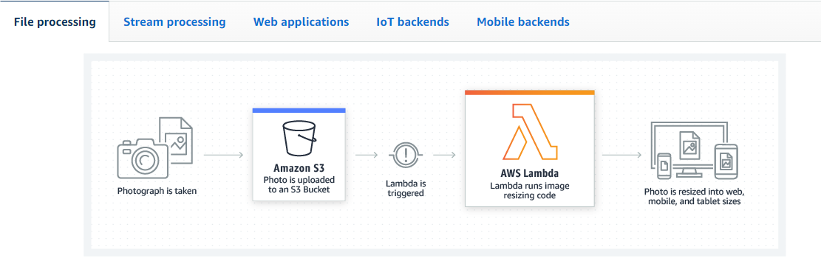eg -> aws lambda

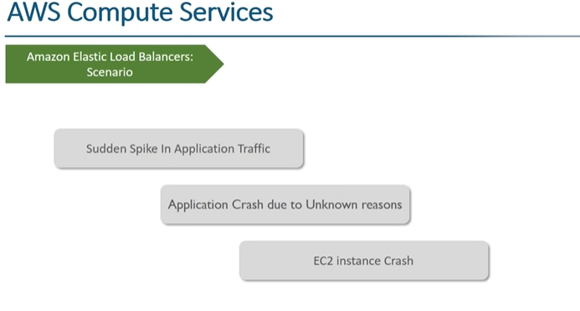

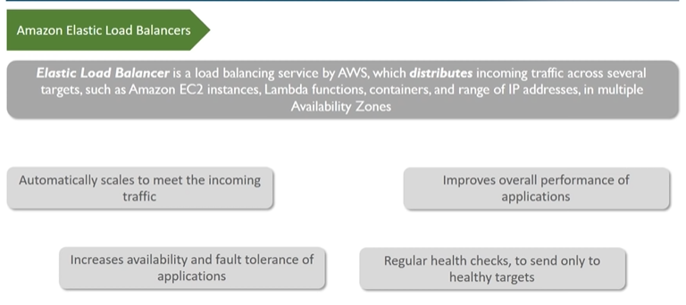

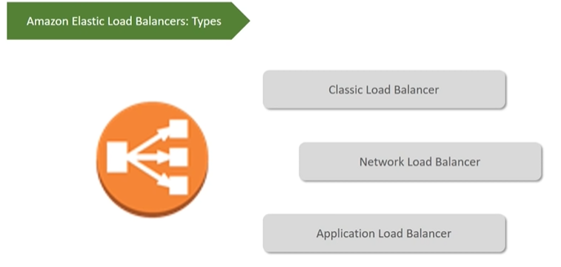

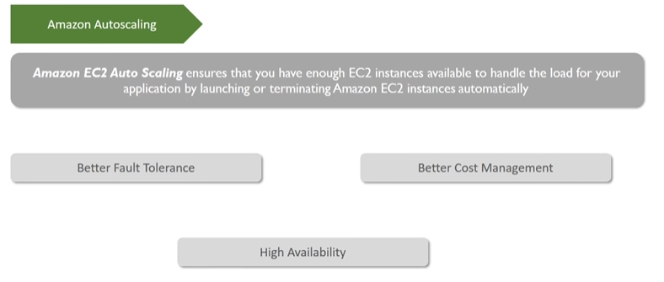

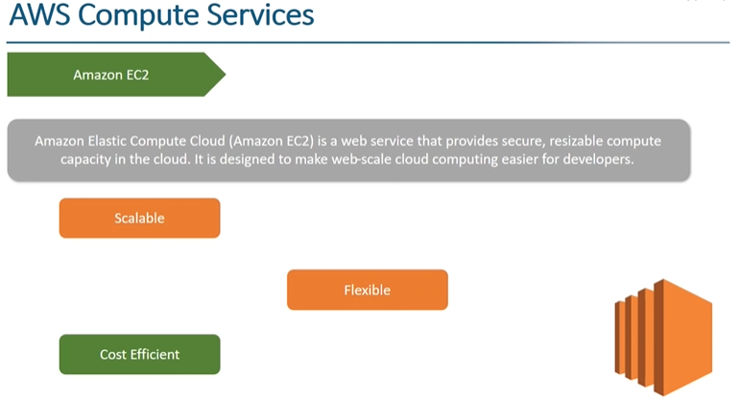

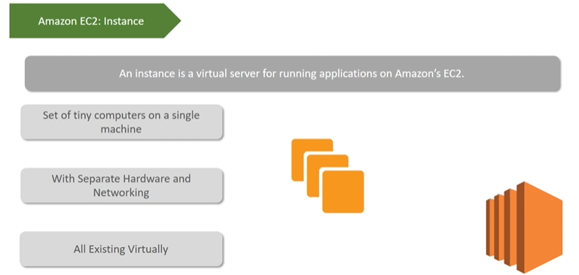Ec2 instance is a Virtual Machine

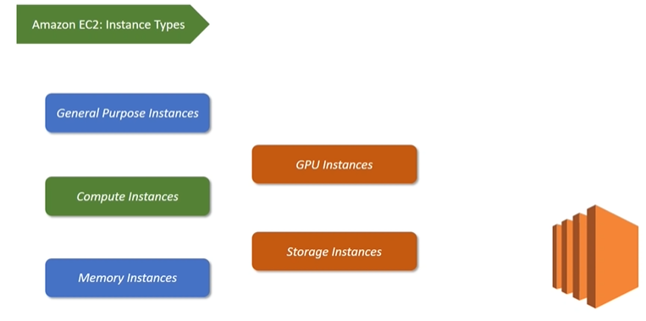

General Purpose

General purpose instances provide a balance of compute, memory and networking resources, and can be used for a variety of diverse workloads. These instances are ideal for applications that use these resources in equal proportions such as web servers and code repositories.

## Compute Optimized

Compute Optimized instances are ideal for compute bound applications that benefit from high performance processors. Instances belonging to this category are well suited for batch processing workloads, media transcoding, high performance web servers, high performance computing (HPC), scientific modeling, dedicated gaming servers and ad server engines, machine learning inference and other compute intensive applications.

## Memory Optimized { RAM}

Memory optimized instances are designed to deliver fast performance for workloads that process large data sets in memory.

Accelerated Computing

Accelerated computing instances use hardware accelerators, or co-processors, to perform functions, such as floating point number calculations, graphics processing, or data pattern matching, more efficiently than is possible in software running on CPUs.

## Storage Optimized

Storage optimized instances are designed for workloads that require high, sequential read and write access to very large data sets on local storage. They are optimized to deliver tens of thousands of low-latency, random I/O operations per second (IOPS) to applications.

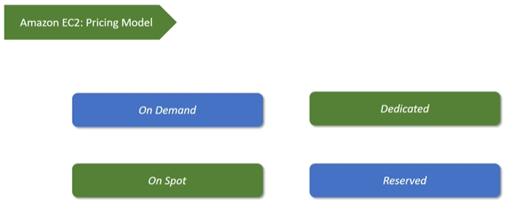

## On-Demand : With On-Demand instances, you pay for compute capacity by the hour or the second depending on which instances you run. No longer-term commitments or upfront payments are needed. You can increase or decrease your compute capacity depending on the demands of your application and only pay the specified per hourly rates for the instance you use.

**On-spot :** people bid for it

**Dedicated :** data critical

**Reserved :** reserving things before

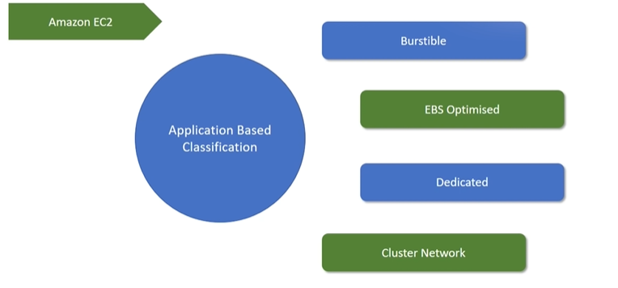EBS -> elastic block storage

# What is AWS Elastic Beanstalk?

With Elastic Beanstalk, you can quickly deploy and manage applications in the AWS Cloud without having to learn about the infrastructure that runs those applications. Elastic Beanstalk reduces management complexity without restricting choice or control. You simply upload your application, and Elastic Beanstalk automatically handles the details of capacity provisioning, load balancing, scaling, and application health monitoring.

Elastic Beanstalk supports applications developed in Go, Java, .NET, Node.js, PHP, Python, and Ruby. When you deploy your application, Elastic Beanstalk builds the selected supported platform version and provisions one or more AWS resources, such as Amazon EC2 instances, to run your application.

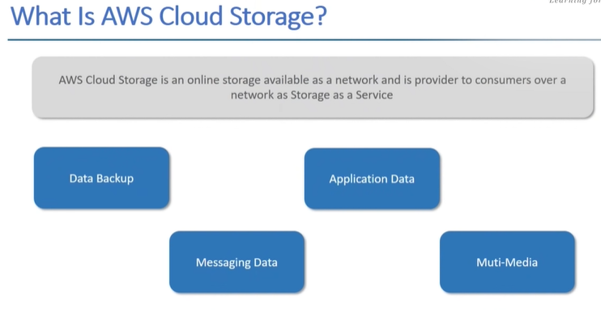

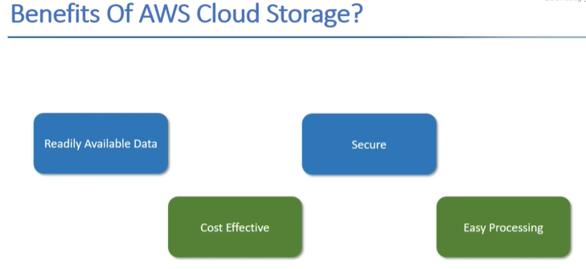

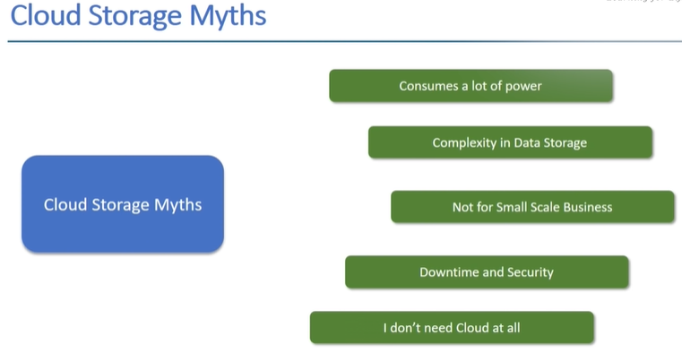

AWS Cloud Storage Services

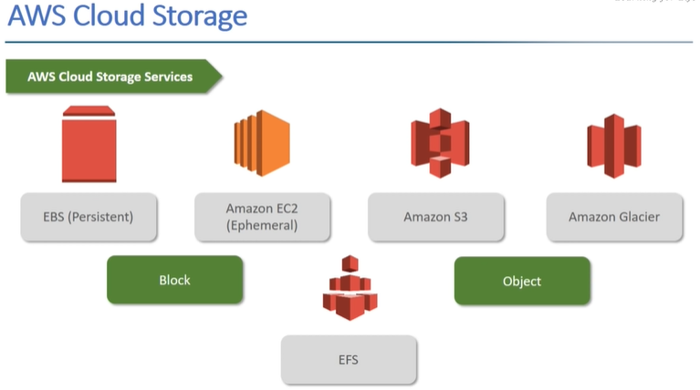 **EFS** -> elastic file storage

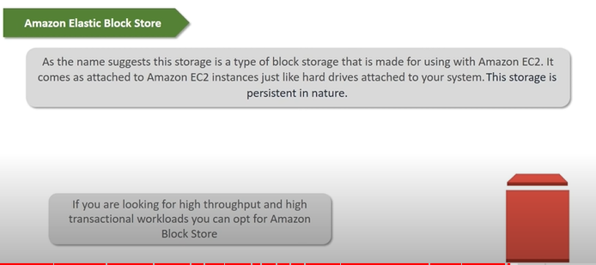

**Persistent** means the data will remain even if instance is removed

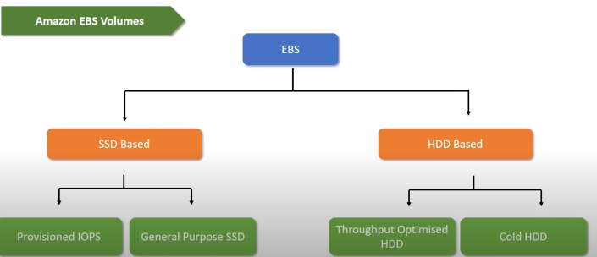

Cold means just need to store data and don’t want it to be accessed at faster rate.

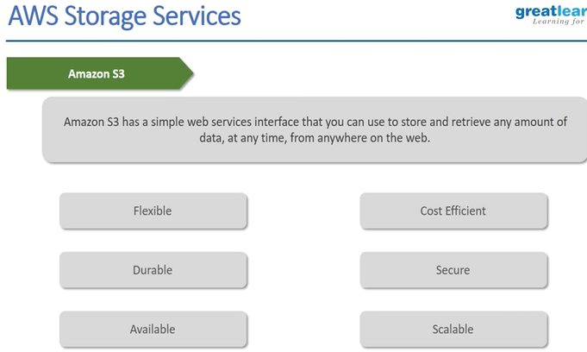S3 -> Simple Storage Service

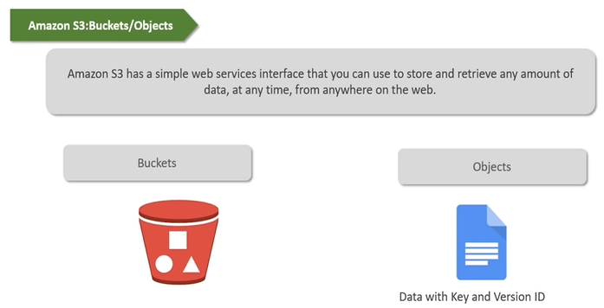

It stores data in form of **bucket**{where data is stored} and **object**{data} , also called as bucket storage

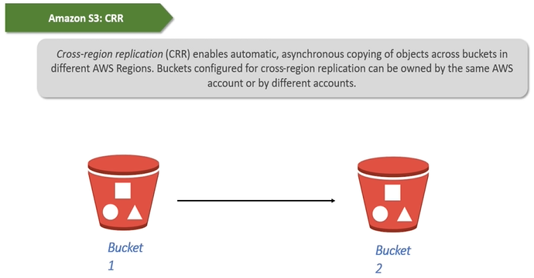

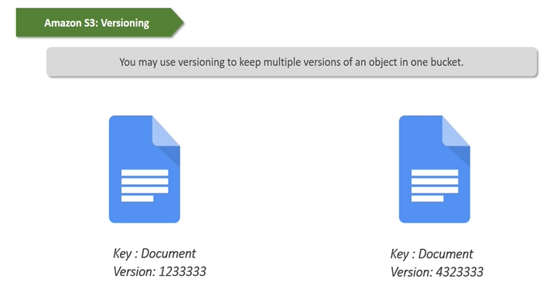

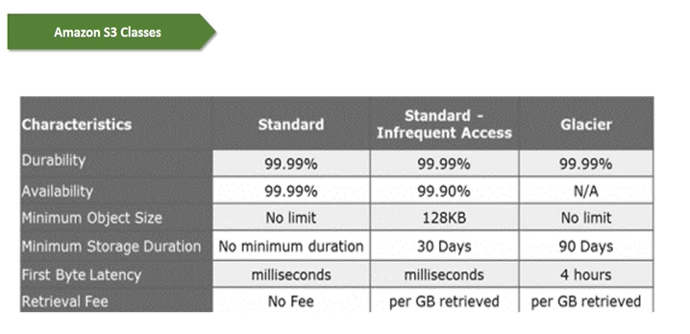

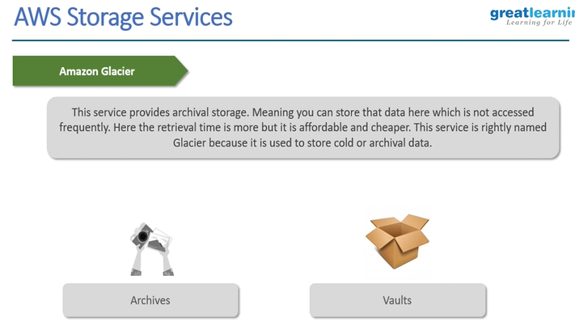

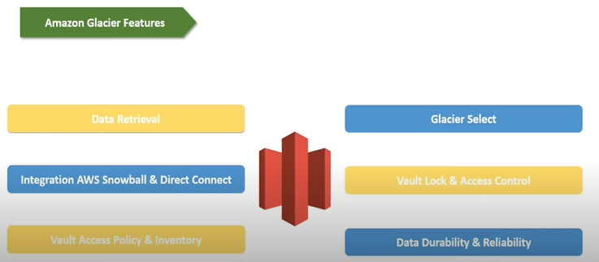

**AWS Security Services :**

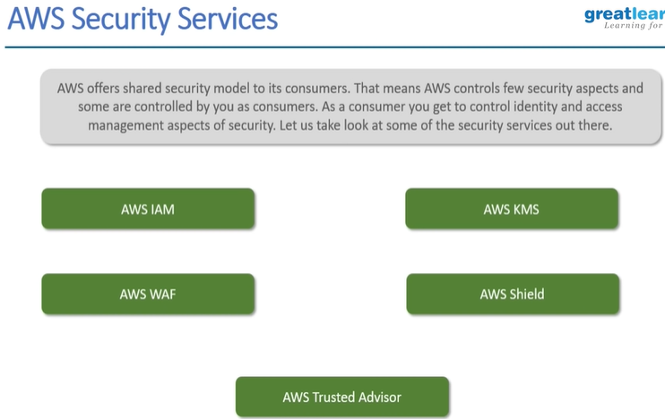

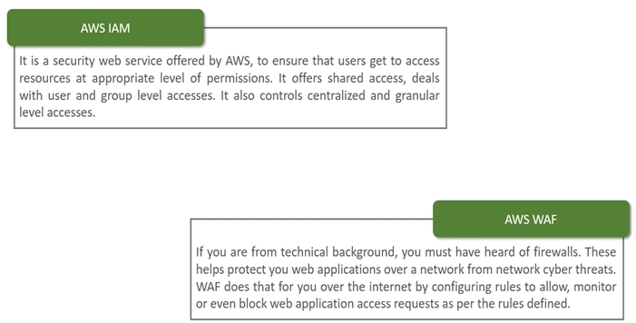

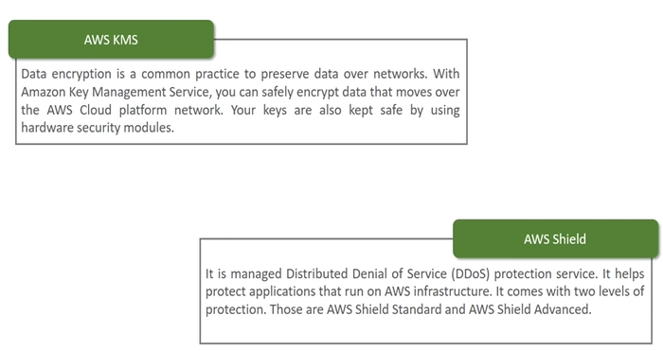

**ddos** -> ek sath kayi false req bhej do .. jise vo crash ho jae

AWS DATABASE SERVICES

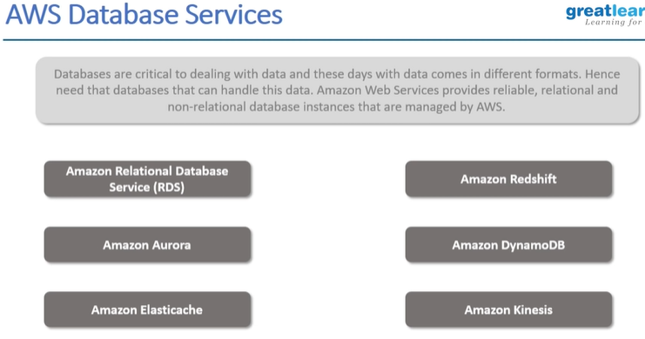

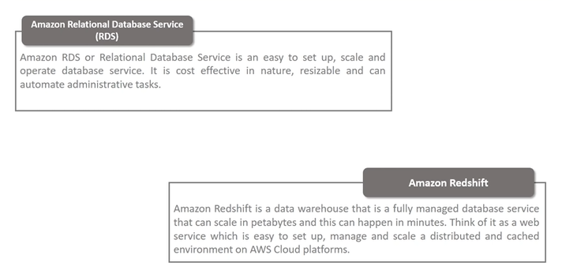

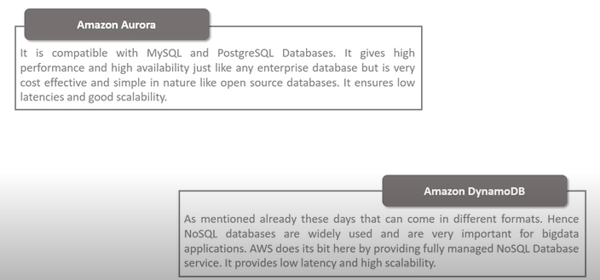

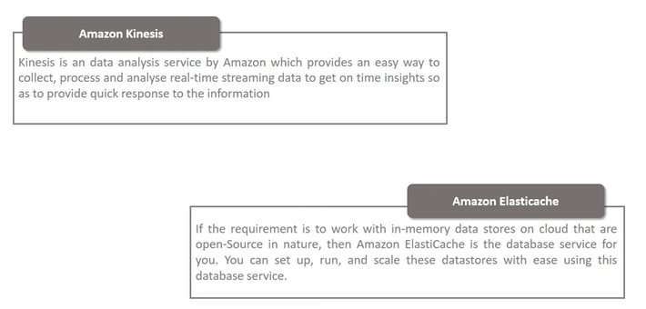

AWS Networking Services

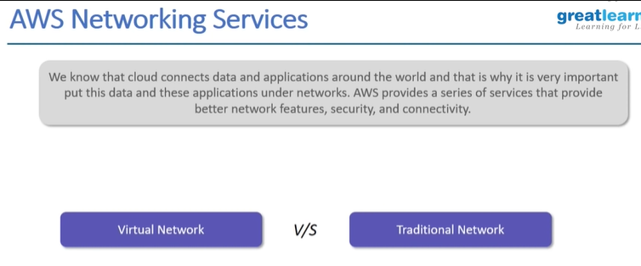

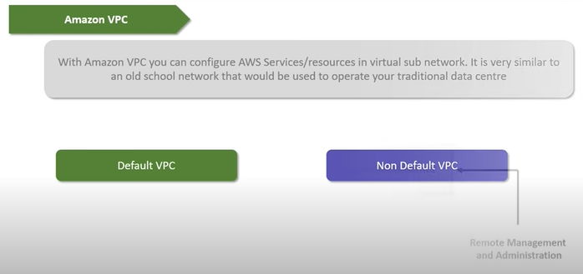

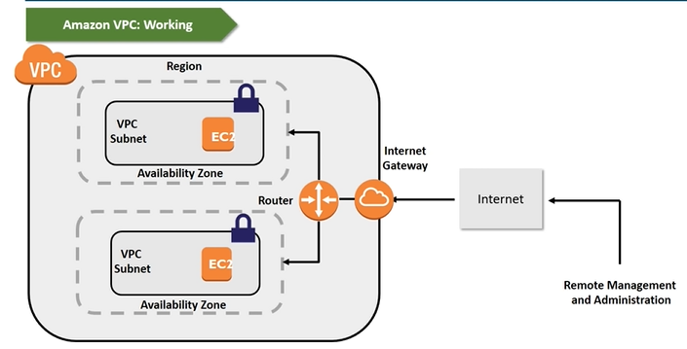

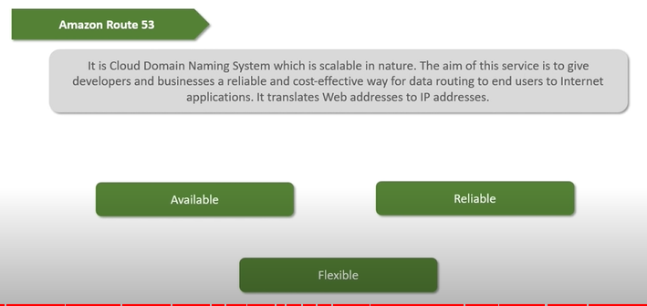

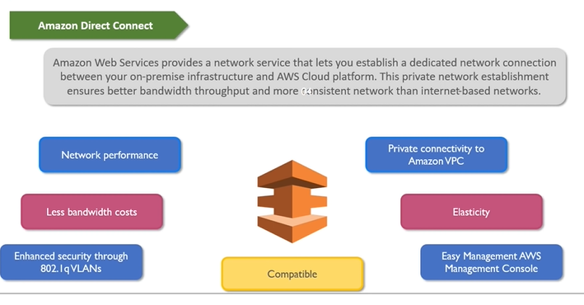

**Demo : AWS VPC**

**AWS DevOps Services**

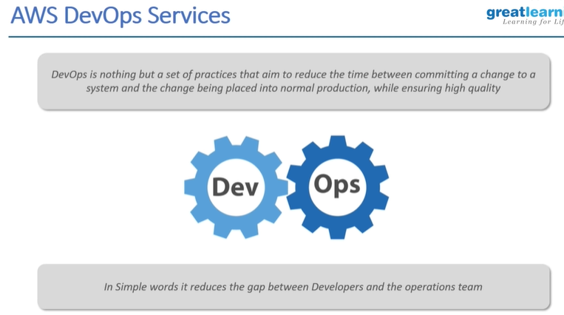

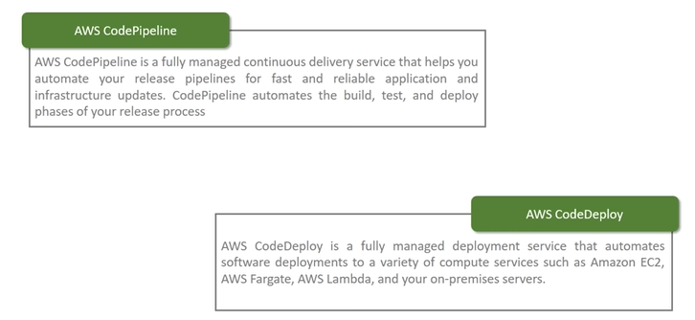

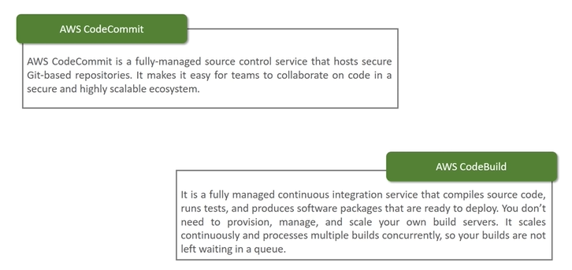

**Demo : DevOps Demo**

**AMAZON SQS :**

**https://www.youtube.com/watch?v=CyYZ3adwboc**

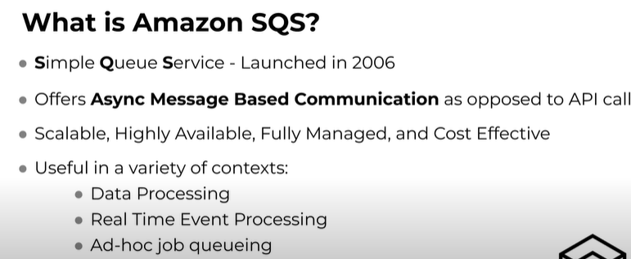



**Part1 ->** <https://www.youtube.com/watch?v=PjsbXzuj_5Y>

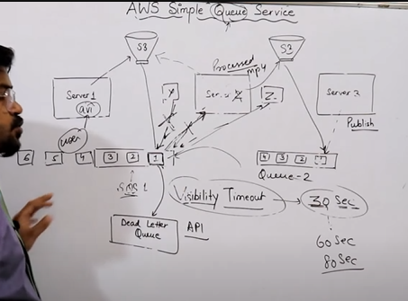 **server is EC2**

**Part2 ->**

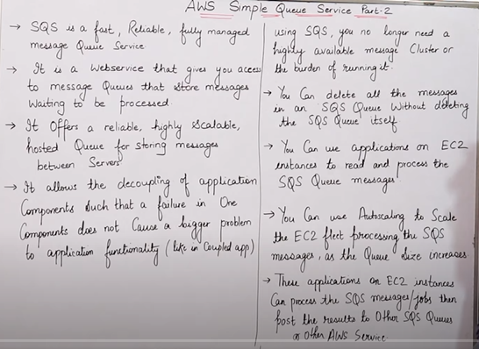**SQS is PULL service**

**SQS is Push service**

**Aws Queue Types : 2 types -> standard and Fifo queue**

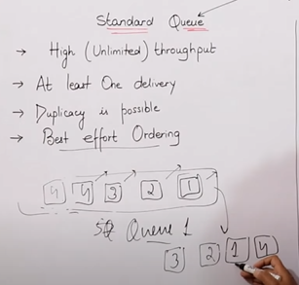 **Tps -> throughput per second**

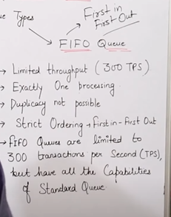

**SQS Pricing:**

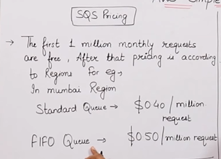

**How Amazon SQS charges:**

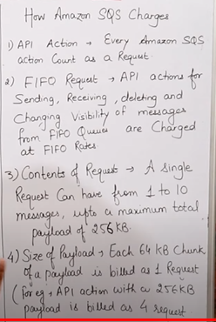

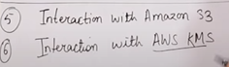

**Part3 ->** <https://www.youtube.com/watch?v=pypjxGaUQHw>

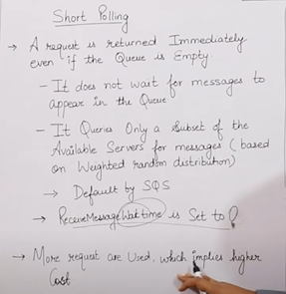 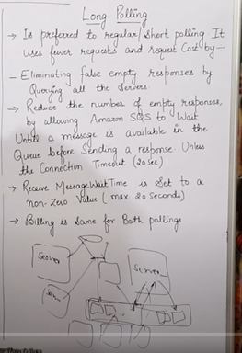

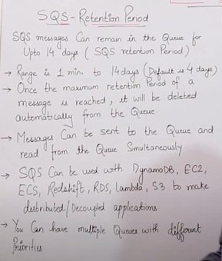 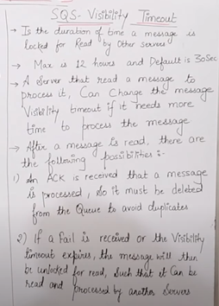

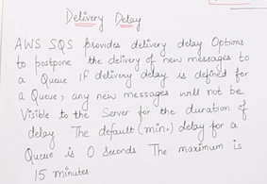  

**SQS Lab Demo :** <https://www.youtube.com/watch?v=dedJqS4WuB4>

# AWS SQS LAB-Hindi/urdu | LEC-95 | AWS SQS Triggers on Lambda function | AWS Simple Queue Service

